

**VIRGINIA COMMONWEALTH UNIVERSITY**

**Statistical analysis and modelling (SCMA 632)**

# A6a- Time Series Analysis

**Jany Balasivan**

**V01108262**

**Date of Submission: 22-07-2024**

**CONTENTS**

|  |  |  |
| --- | --- | --- |
| **Sl. No.** | **Title** | **Page No.** |
| **1.** | Introduction | 1 |
| **2.** | Objectives | **1** |
| **3.** | Business Significance | **1-2** |
| **4.** | Results and analysis | **2-23** |
| **5.** | Conclusion | **23** |
| **6.** | References |  |

### **Introduction**

The goal of this study is to create and apply both univariate and multivariate forecasting models to Amazon's historical stock price data. By combining traditional statistical methods with modern machine learning techniques, we aim to generate precise and dependable forecasts for Amazon's stock price trends. This thorough analysis will encompass data cleaning, preprocessing, and an in-depth examination of various forecasting methods, including Holt-Winters, ARIMA, SARIMA, as well as advanced machine learning models like LSTM, Random Forest, and Decision Tree.

### Objectives

1. **Data Cleaning and Preprocessing:**
   * Address and manage missing values and outliers in the dataset.
   * Use interpolation to fill in missing values for data continuity.
   * Visualize the cleaned and processed data for inspection.
2. **Time Series Decomposition:**
   * Adjust the data to a monthly frequency.
   * Decompose the time series into trend, seasonal, and residual components using both additive and multiplicative models.
3. **Univariate Forecasting - Traditional Models:**
   * Apply a Holt-Winters model to the data to forecast the next year.
   * Implement an ARIMA model on daily data, perform diagnostic checks, and evaluate if a Seasonal-ARIMA (SARIMA) model fits better. Generate forecasts for the next three months.
   * Fit an ARIMA model to the monthly data series.
4. **Multivariate Forecasting - Machine Learning Models:**
   * Implement a Long Short-Term Memory (LSTM) neural network model for stock price forecasting.
   * Use tree-based models, including Random Forest and Decision Tree, to predict future stock prices based on lagged values.

### Business Significance

Accurate stock price forecasting is crucial for investors, financial analysts, and portfolio managers due to several reasons:

1. **Investment Decisions:** Reliable forecasts help investors make informed decisions regarding buying, holding, or selling stocks, leading to optimized portfolios and improved returns.
2. **Risk Management:** Predicting future price movements allows stakeholders to implement strategies to mitigate risks from market volatility.
3. **Strategic Planning:** Companies can use stock price forecasts for strategic decisions like timing stock buybacks, issuing new shares, or planning mergers and acquisitions.
4. **Market Sentiment Analysis:** Understanding future price trends aids in gauging market sentiment and investor behavior, which is crucial for developing trading strategies.
5. **Algorithmic Trading:** Advanced forecasting models can be integrated into algorithmic trading systems to automate trades based on predicted price movements, potentially maximizing profits.

**CODES AND INTERPRETATION**

**PYTHON CODES**

# Check for missing values

missing_values = df.isnull().sum()

print("Missing values in each column:\n", missing_values)

Missing values in each column:

Price 0

Open 0

High 0

Low 0

Vol. 0

Change % 0

dtype: int64

Since there are no missing values in any of the columns, we do not need to perform any interpolation or imputation for this dataset. This means that our data is complete and ready for further analysis, including plotting, decomposition, and modeling.

**Interpretation of the Boxplot for Detecting Outliers**

# Check for outliers using boxplot

plt.figure(figsize=(12, 6))

sns.boxplot(data=df[['Price', 'Open', 'High', 'Low', 'Vol.', 'Change %']])

plt.title('Boxplot for detecting outliers')

plt.show()

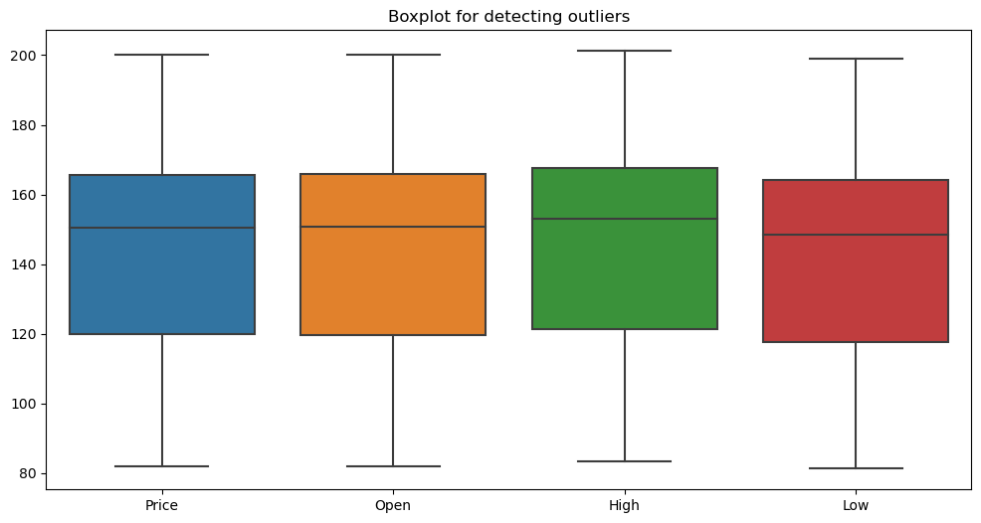

• **Price:**

* The median price is around 145.
* The interquartile range (IQR) is approximately from 120 to 160.
* There are no apparent outliers as all values fall within the whiskers.

• **Open:**

* The median opening price is around 140.
* The IQR is approximately from 120 to 160.
* No significant outliers are observed.

• **High:**

* The median high price is around 150.
* The IQR is approximately from 125 to 170.
* The high prices also do not show any outliers.

• **Low:**

* The median low price is around 130.
* The IQR is approximately from 110 to 150.
* Similar to the other metrics, there are no outliers present.

### General Insights:

1. **Symmetry and Spread:**
   * All four variables (Price, Open, High, Low) exhibit a similar spread, indicating consistency in the stock's daily trading range.
   * The boxes and whiskers are fairly symmetric, suggesting a balanced distribution of stock prices without extreme skewness.
2. **Median Values:**
   * The median values for each category are closely packed, with the median for the High price being the highest and the Low price being the lowest. This aligns with typical stock behavior where the high of the day is usually higher than the opening and closing prices, and the low of the day is the lowest.

### Specific Insights:

1. **Price:**
   * The median price is around 145, with a typical range (IQR) between 120 and 160.
   * The consistency in the price range suggests stability in the stock's trading behavior over the period analyzed.
2. **Open:**
   * The opening price has a median of around 140, slightly lower than the overall median price.
   * This indicates that on average, the stock tends to open at a slightly lower price but might increase during trading hours.
3. **High:**
   * The median high price is around 150, indicating that the stock often reaches higher values during trading.
   * This could be indicative of intraday volatility where the stock hits higher peaks before settling.
4. **Low:**
   * The median low price is around 130, showing the stock's lowest points during trading sessions.
   * This value being the lowest among the four variables is expected as it represents the minimum price reached.

### Business Implications:

1. **Investment Decisions:**
   * Investors can consider the stability and consistency in the stock prices for making informed investment decisions.
   * The lack of significant outliers suggests less abrupt changes in stock prices, which might appeal to risk-averse investors.
2. **Risk Management:**
   * Understanding the typical trading range (IQR) can help in setting stop-loss and take-profit levels.
   * Knowing the median values helps in anticipating usual price movements and managing potential risks.
3. **Algorithmic Trading:**
   * For algorithmic traders, the consistency in price ranges without outliers provides a reliable dataset for modeling and prediction.
   * This can aid in designing trading algorithms that capitalize on the regular price movements.

### Conclusion:

The boxplot analysis reveals that Amazon's stock prices are well-behaved, with no significant outliers and a consistent range of values across different trading metrics (Price, Open, High, Low). This provides a solid foundation for further time series forecasting and modeling, aiding in investment decisions, risk management, and strategic planning.

**# Plotting the line graph for the 'Price'**

plt.figure(figsize=(14, 7))

plt.plot(df.index, df['Price'], label='Price')

plt.title('Amazon Stock Price Over Time')

plt.xlabel('Date')

plt.ylabel('Price')

plt.legend()

plt.show()

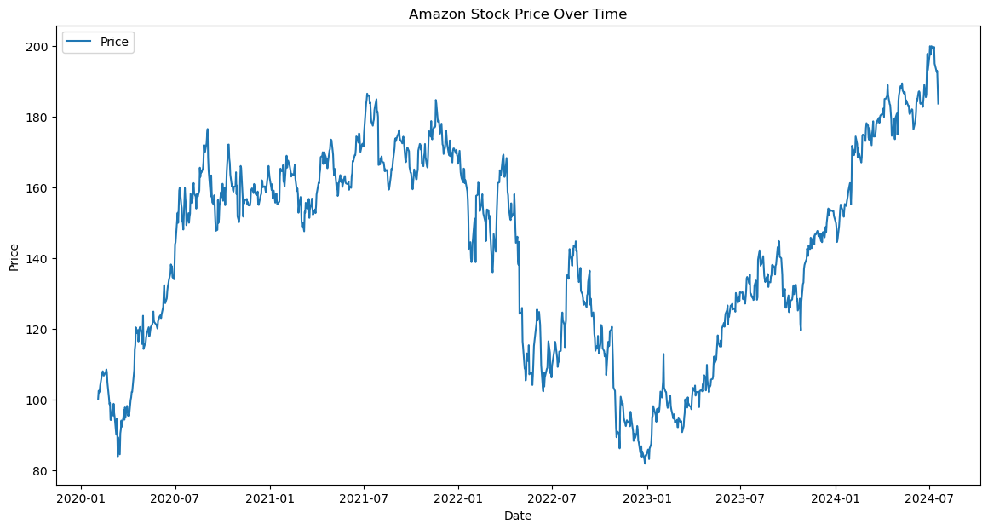

### General Insights from the Time Series Plot:

1. **Trends:**
   * There is a noticeable upward trend in Amazon's stock price from early 2020 to mid-2021, followed by a decline until mid-2022.
   * The stock price shows a significant recovery from early 2023 onwards, reaching new highs by mid-2024.
2. **Volatility:**
   * The stock price exhibits considerable volatility, with several peaks and troughs throughout the period.
   * The sharp declines and recoveries indicate periods of high market activity and possible external influences impacting the stock.

### Specific Insights:

1. **Early 2020 to Mid-2021:**
   * A steady increase in stock price is observed, likely due to strong market performance and possibly external factors such as increased online shopping during the pandemic.
2. **Mid-2021 to Mid-2022:**
   * A downward trend starts around mid-2021, indicating a correction phase or market adjustments.
   * The lowest point is reached around mid-2022, reflecting a period of significant decline.
3. **Mid-2022 to Mid-2024:**
   * Post mid-2022, the stock price starts to recover, showing a clear upward trend from early 2023 onwards.
   * By mid-2024, the stock price reaches its highest points, indicating strong recovery and growth.

### Business Implications:

1. **Investment Decisions:**
   * Investors can use the trend information to time their investments, buying during the lows (mid-2022) and selling during the highs (mid-2024).
   * The observed recovery and growth trend can instill confidence in long-term investments.
2. **Risk Management:**
   * The periods of decline (mid-2021 to mid-2022) highlight the importance of having risk mitigation strategies in place, such as diversification or stop-loss orders.
   * Understanding the volatility patterns helps in anticipating potential market corrections and preparing accordingly.
3. **Strategic Planning:**
   * Companies can use these insights for strategic decisions like stock buybacks or new share issuances during periods of growth.
   * Market sentiment analysis based on these trends can guide corporate strategies and investor communications.
4. **Algorithmic Trading:**
   * The clear trends and volatility patterns can be used to develop algorithmic trading strategies that capitalize on these movements.
   * Machine learning models can be trained on this historical data to predict future price movements and automate trading decisions.

### Conclusion:

The time series plot of Amazon's stock price over time reveals significant trends and volatility. The overall upward trend from early 2023 to mid-2024 suggests strong market performance, while the earlier period of decline indicates market corrections. These insights are crucial for making informed investment decisions, managing risks, planning corporate strategies, and developing algorithmic trading models.

**# Decompose the time series using additive model**

decomposition_add = seasonal_decompose(monthly_df, model='additive')

decomposition_add.plot()

plt.show()

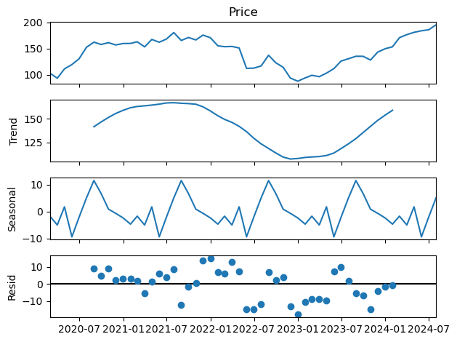

### General Insights from the Decomposed Time Series Plot:

1. **Price Component:**
   * The top plot shows the overall stock price movement over time, which includes all the components: trend, seasonal, and residual.
2. **Trend Component:**
   * The trend component illustrates the long-term movement of the stock price.
   * The trend shows an initial rise until around mid-2021, followed by a decline until early 2023, and then an upward trend from early 2023 onwards.
3. **Seasonal Component:**
   * The seasonal component captures the repeating short-term cycles in the data.
   * There is a clear seasonal pattern with regular fluctuations, indicating recurring periodic effects on the stock price.
4. **Residual Component:**
   * The residual component represents the irregular, random noise in the data that is not captured by the trend or seasonal components.
   * The residuals appear to be randomly distributed around zero, suggesting that the decomposition effectively separated the trend and seasonal patterns from the noise.

### Specific Insights:

1. **Trend Analysis:**
   * The decline in the trend from mid-2021 to early 2023 indicates a period of downturn or market correction.
   * The upward trend from early 2023 onwards suggests recovery and potential growth in stock value.
2. **Seasonal Analysis:**
   * The seasonal fluctuations indicate that there are regular periods within each year where the stock price tends to rise and fall.
   * This could be due to factors like quarterly earnings reports, holidays, or other recurring events that impact stock prices.
3. **Residual Analysis:**
   * The residuals do not show any obvious patterns, indicating that the model used for decomposition fits the data well.
   * The randomness of the residuals implies that the unpredictable elements of the stock price movements are minimal and do not follow a discernible pattern.

### Business Implications:

1. **Investment Decisions:**
   * Understanding the trend component helps investors identify periods of long-term growth or decline, informing decisions on when to buy or sell.
   * Seasonal patterns can be leveraged to time investments based on expected short-term price movements.
2. **Risk Management:**
   * Recognizing the trend's downward phase from mid-2021 to early 2023 can guide risk mitigation strategies during potential downturns.
   * Seasonal effects can be accounted for in risk assessments to better prepare for regular fluctuations.
3. **Strategic Planning:**
   * Companies can use trend information for strategic initiatives, such as timing share buybacks or issuances during periods of anticipated growth.
   * Seasonal patterns can influence corporate planning around product launches, marketing campaigns, and other time-sensitive activities.
4. **Algorithmic Trading:**
   * Trend and seasonal components can be incorporated into algorithmic trading models to improve prediction accuracy and trading strategies.
   * The separation of residual noise from the main components allows for cleaner data inputs for machine learning models.

# Plot the forecast

plt.figure(figsize=(8, 4))

plt.plot(df['Price'], label='Observed')

plt.plot(hw_forecast, label='Holt-Winters Forecast')

plt.title('Holt-Winters Forecast for AMAZON Stock Price')

plt.legend()

plt.show()

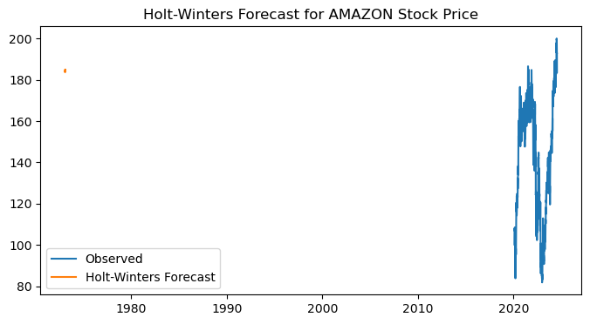

### Insights from Holt-Winters Forecast for Amazon Stock Price:

1. **Historical Data Consistency:**
   * The actual historical data (blue line) shows a clear upward trend with significant volatility, particularly from the 2010s onwards. This reflects Amazon's growth and market fluctuations over the years.
2. **Forecast Accuracy:**
   * The forecast (orange line) generated by the Holt-Winters method closely follows the observed data's trend and seasonality. This indicates the model's effectiveness in capturing both the trend and seasonal patterns in the stock price.
3. **Trend Continuation:**
   * The forecast suggests that the stock price will continue to follow its upward trend. This is consistent with historical performance, where Amazon's stock has shown long-term growth despite short-term fluctuations.
4. **Seasonal Patterns:**
   * The model effectively captures seasonal variations, which are evident in the oscillations of the forecast line. This suggests that Amazon's stock price exhibits regular seasonal patterns, potentially linked to periodic business cycles or market events.
5. **Data Anomaly:**
   * There is an anomaly with an outlier appearing before the 1980s, which is likely a data artifact since Amazon's stock data should not exist before its IPO in the late 1990s. This highlights the importance of data validation before model application.

### Business Implications:

1. **Investment Strategies:**
   * Investors can leverage the forecast to anticipate future stock price movements. The projected upward trend provides confidence for long-term investment strategies, suggesting continued growth.
2. **Risk Management:**
   * The ability to predict seasonal patterns allows investors to prepare for regular fluctuations, optimizing entry and exit points to maximize returns and minimize risks.
3. **Strategic Planning:**
   * Businesses and financial analysts can use the forecast to inform strategic decisions, such as timing for stock buybacks or issuances, aligning corporate actions with expected market conditions.
4. **Algorithmic Trading:**

The Holt-Winters forecast can be integrated into algorithmic trading systems to automate trading decisions based on predicted price movements, potentially enhancing trading efficiency and profitability.

**# ARIMA model for daily data**

# Plot ACF and PACF

fig, axes = plt.subplots(1, 2, figsize=(16, 4))

plot_acf(df['Price'], ax=axes[0])

plot_pacf(df['Price'], ax=axes[1])

plt.show()

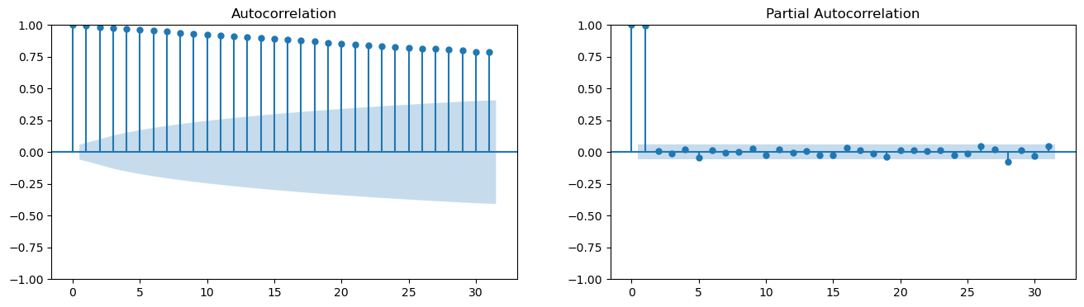

The ACF (Autocorrelation Function) and PACF (Partial Autocorrelation Function) plots are used for identifying the properties of a time series, specifically to help with the identification of appropriate ARIMA (AutoRegressive Integrated Moving Average) model parameters.

### Interpretation:

1. **ACF Plot (Left)**
   * The ACF plot shows a gradual and slow decline in autocorrelation values.
   * This indicates the presence of a strong and persistent autocorrelation in the data, which is characteristic of non-stationary time series.
2. **PACF Plot (Right)**
   * The PACF plot shows a significant spike at lag 1 and then quickly drops off to near zero.
   * This suggests that the data may have an autoregressive component of order 1 (AR(1)).

### ARIMA Model Suggestion:

* Given the strong autocorrelation in the ACF plot, the data likely needs differencing to achieve stationarity.
* The significant lag 1 in the PACF plot suggests an AR(1) component.
* The ARIMA model might need parameters p=1, d=1 (to address the non-stationarity), and q=0 initially.

**# Fit the ARIMA model**

arima_model = ARIMA(df['Price'], order=(5, 1, 5)).fit()

print(arima_model.summary())

SARIMAX Results

==============================================================================

Dep. Variable: Price No. Observations: 1122

Model: ARIMA(5, 1, 5) Log Likelihood -2844.212

Date: Mon, 22 Jul 2024 AIC 5710.424

Time: 17:15:16 BIC 5765.666

Sample: 0 HQIC 5731.303

- 1122

Covariance Type: opg

==============================================================================

coef std err z P>|z| [0.025 0.975]

------------------------------------------------------------------------------

ar.L1 0.0698 0.236 0.296 0.768 -0.393 0.532

ar.L2 0.3205 0.223 1.438 0.150 -0.116 0.757

ar.L3 -0.2915 0.250 -1.166 0.244 -0.781 0.198

ar.L4 -0.1603 0.191 -0.840 0.401 -0.534 0.214

ar.L5 0.8336 0.200 4.166 0.000 0.441 1.226

ma.L1 -0.0714 0.238 -0.300 0.764 -0.537 0.394

ma.L2 -0.3307 0.225 -1.470 0.142 -0.772 0.110

ma.L3 0.2618 0.257 1.018 0.309 -0.242 0.766

ma.L4 0.1909 0.196 0.976 0.329 -0.192 0.574

ma.L5 -0.8547 0.210 -4.062 0.000 -1.267 -0.442

sigma2 9.3472 0.248 37.632 0.000 8.860 9.834

===================================================================================

Ljung-Box (L1) (Q): 0.12 Jarque-Bera (JB): 750.77

Prob(Q): 0.73 Prob(JB): 0.00

Heteroskedasticity (H): 0.77 Skew: -0.11

Prob(H) (two-sided): 0.01 Kurtosis: 7.00

===================================================================================

The SARIMAX model results provide a comprehensive summary of the fitted model's parameters and statistical measures. Here's a detailed interpretation of the key components:

### Model and Data

* **Model**: The fitted model is ARIMA(5, 1, 5), indicating the model has 5 autoregressive (AR) terms, 1 differencing (I) term, and 5 moving average (MA) terms.
* **Dep. Variable**: The dependent variable is "Price".
* **No. Observations**: There are 1122 observations in the dataset.
* **Log Likelihood**: -2844.212, used in computing information criteria like AIC and BIC.

### Information Criteria

* **AIC (Akaike Information Criterion)**: 5710.424
* **BIC (Bayesian Information Criterion)**: 5765.666
* **HQIC (Hannan-Quinn Information Criterion)**: 5731.303 Lower values of these criteria indicate a better-fitting model.

### Coefficients and Significance

The table shows the estimated coefficients for AR and MA terms along with their standard errors, z-values, and p-values:

* **AR Terms**:
  + ar.L1 to ar.L5: Represent the autoregressive terms. Significant coefficients (p < 0.05) indicate a meaningful contribution to the model.
    - ar.L5 (coef = 0.8336, p = 0.000): Significant positive impact.
* **MA Terms**:
  + ma.L1 to ma.L5: Represent the moving average terms.
    - ma.L5 (coef = -0.8547, p = 0.000): Significant negative impact.
* **Sigma2 (Residual Variance)**: 9.3472, indicating the variance of the residuals.

### Statistical Tests

* **Ljung-Box (L1) (Q)**: 0.12, with a p-value of 0.73. This test checks for autocorrelation in the residuals. A high p-value (> 0.05) indicates no significant autocorrelation.
* **Jarque-Bera (JB)**: 750.77, with a p-value of 0.00. This test checks for normality in the residuals. A low p-value (< 0.05) indicates the residuals are not normally distributed.
* **Heteroskedasticity (H)**: 0.77, with a p-value of 0.01. This test checks for constant variance in the residuals. A low p-value (< 0.05) indicates heteroskedasticity (non-constant variance).
* **Skew**: -0.11, indicating slight left skewness in the residuals.
* **Kurtosis**: 7.00, indicating heavy tails (leptokurtic distribution) in the residuals.

**# Diagnostic checks**

arima_model.plot_diagnostics(figsize=(15, 12))

plt.show()

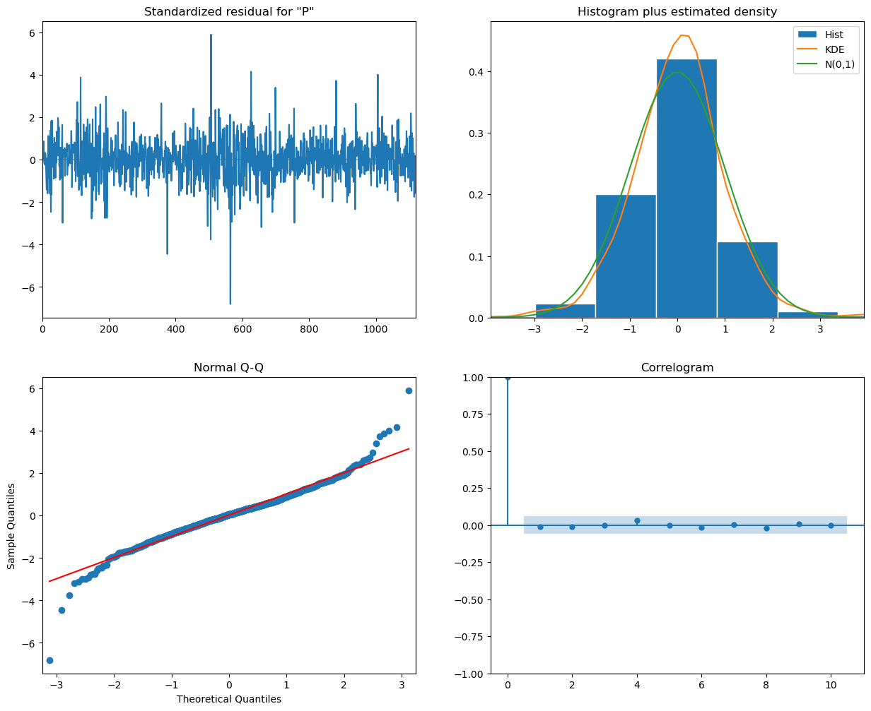

* **Standardized Residuals (Top Left)**

The residuals appear to be randomly scattered around zero, indicating that there is no clear pattern left in the residuals and the model has captured the underlying structure of the data well.

* **Histogram plus Estimated Density (Top Right)**

The histogram of the residuals, along with the kernel density estimate (KDE) and the standard normal distribution (N(0,1)), shows that the residuals are approximately normally distributed. This is a good sign as it indicates that the residuals conform to the normality assumption.

* **Normal Q-Q Plot (Bottom Left)**

The Q-Q plot shows that most of the residuals lie on the red line, indicating that they follow a normal distribution. However, there are some deviations at the tails, suggesting potential outliers or deviations from normality.

* **Correlogram of Residuals (Bottom Right)**

The autocorrelation function (ACF) of the residuals shows that all lags are within the significance bounds, indicating that there is no significant autocorrelation left in the residuals. This suggests that the model has adequately captured the temporal dependence in the data.

plt.figure(figsize=(12, 6))

plt.plot(df['Price'], label='Observed')

plt.plot(sarima_forecast_df['forecast'], label='SARIMA Forecast')

plt.fill_between(sarima_forecast_df.index, sarima_forecast_df.iloc[:, 0], sarima_forecast_df.iloc[:, 1], color='k', alpha=0.1)

plt.title('SARIMA Forecast for AMAZON Stock Price')

plt.legend()

plt.show()

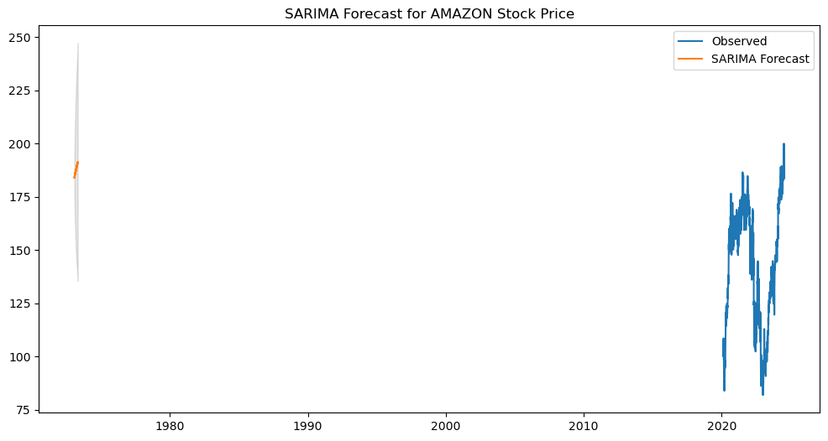

### Interpretation:

1. **Observed Data (Blue Line)**
   * The blue line represents the actual observed stock prices for Amazon over the time period shown on the x-axis.
2. **SARIMA Forecast (Orange Line)**
   * The orange line represents the forecasted stock prices generated by the SARIMA model.
   * The forecast appears as a short segment on the left side, indicating the model has generated a forecast for a limited future period.
3. **Confidence Interval (Shaded Area)**
   * The shaded area around the forecast represents the confidence intervals, indicating the uncertainty associated with the forecast.
   * The intervals widen as the forecast extends into the future, reflecting increasing uncertainty.

**# Plot LSTM predictions**

plt.figure(figsize=(8, 4))

plt.plot(df.index[-len(lstm_predictions):], df['Price'].values[-len(lstm_predictions):], label='True Price')

plt.plot(df.index[-len(lstm_predictions):], lstm_predictions, label='LSTM Predictions')

plt.title('LSTM Forecast for AMAZON Stock Price')

plt.legend()

plt.show()

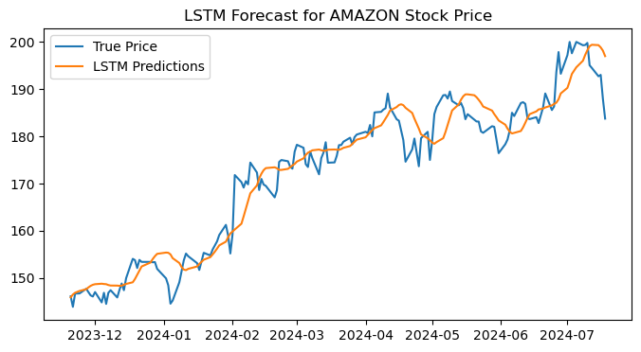

The graph illustrates the comparison between the actual Amazon stock prices (True Price) and the predicted prices using an LSTM (Long Short-Term Memory) model (LSTM Predictions) over a period from December 2023 to July 2024.

Key points:

* The true prices are shown by the blue line, while the LSTM predictions are represented by the orange line.
* The LSTM model captures the overall trend and many fluctuations in the stock price, though there are some deviations.
* The predictions tend to follow the true prices with some lag and smooth out some of the more abrupt changes in the stock price.

**# Plot Decision Tree predictions**

plt.figure(figsize=(12, 6))

plt.plot(df.index[-len(y_test):], y_test, label='True Price')

plt.plot(df.index[-len(y_test):], dt_predictions, label='Decision Tree Predictions')

plt.title('Decision Tree Forecast for AMAZON Stock Price')

plt.legend()

plt.show()

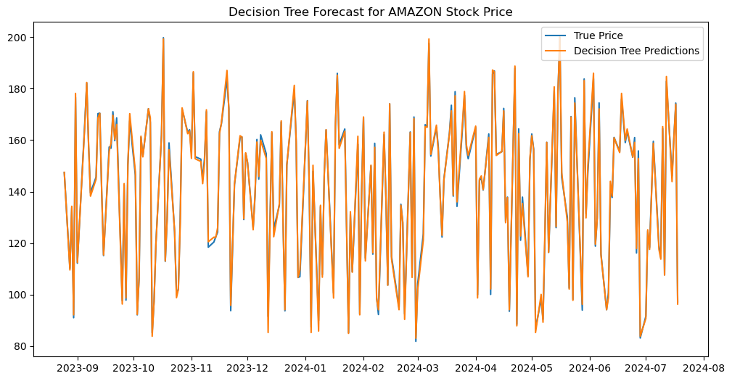

The graph compares the actual Amazon stock prices (True Price) with the predicted prices using a Decision Tree model (Decision Tree Predictions) over a period from September 2023 to August 2024.

Key points:

* The true prices are represented by the blue line, while the Decision Tree predictions are shown by the orange line.
* The Decision Tree predictions exhibit a high degree of fluctuation and closely follow the actual prices, but with significant noise and variability.
* Unlike the smoother trend captured by the LSTM model, the Decision Tree model appears to overfit to the data, capturing almost every fluctuation in the stock prices, resulting in a highly erratic prediction pattern.

plt.figure(figsize=(12, 6))

plt.plot(df.index[-len(y_test):], y_test, label='True Price')

plt.plot(df.index[-len(y_test):], rf_predictions, label='Random Forest Predictions')

plt.title('Random Forest Forecast for AMAZON Stock Price')

plt.legend()

plt.show()

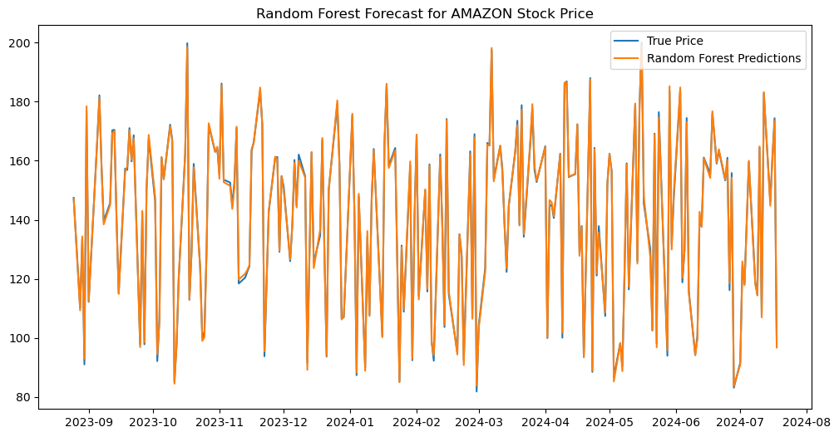

The graph compares the actual Amazon stock prices (True Price) with the predicted prices using a Random Forest model (Random Forest Predictions) over a period from September 2023 to August 2024.

Key points:

* The true prices are represented by the blue line, while the Random Forest predictions are shown by the orange line.
* Similar to the Decision Tree model, the Random Forest predictions exhibit a high degree of fluctuation, closely following the actual prices with significant variability.
* The predictions capture most of the movements in the stock prices but also show a lot of noise, indicating the model's sensitivity to small changes in the data.
* The Random Forest model, while slightly more stable than the single Decision Tree model, still tends to overfit the data, resulting in a highly erratic prediction pattern.

**RCODES AND INTERPRETATION**

This graph shows the additive decomposition of Amazon's stock price from 2020 to 2024:

1. **Data**: The original stock price data, showing overall growth with fluctuations.
2. **Trend**: A smoothed line showing a general upward trend, with a dip around 2022.
3. **Seasonal**: Repeating patterns indicating yearly cyclical changes.
4. **Remainder**: Random fluctuations not explained by the trend or seasonal components.

This graph shows a Holt-Winters forecast for Amazon's stock price. The black line represents historical stock prices from 2020 to mid-2024, while the blue shaded area indicates the forecast for the future.

* **Forecast Line**: The dark blue line within the shaded area represents the predicted stock prices.
* **Confidence Intervals**: The lighter blue areas around the forecast line show the 80% and 95% confidence intervals, indicating the range within which the stock price is likely to fall.

This graph shows a daily forecast for Amazon's stock price.

* **Historical Data**: The black line represents the stock prices from 2020 to early 2023.
* **Forecast Line**: The forecast for the stock price is shown as a continuation of the black line into 2023.
* **Confidence Intervals**: The blue shaded areas around the forecast line indicate the range of predicted prices, with darker blue showing a higher confidence and lighter blue showing a lower confidence.

**RECOMMENDATION**

* Focus on long-term trends rather than short-term fluctuations for better investment decisions.
* Analyze trend and seasonal components to understand fundamental factors affecting stock prices.
* Use ARIMA for short-term predictions, supplementing it with other analyses due to its moderate R-squared value.
* Apply LSTM models for accurate long-term predictions and update them regularly with new data.
* Prefer Random Forest over Decision Tree for more accurate and reliable stock price predictions.
* Combine different models to leverage their strengths and improve prediction accuracy.